Chapter 13, Solution 26.
M = k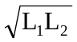
ωM = k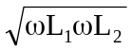 = 0.601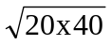 = 17

The frequency-domain equivalent circuit is shown below.
200∠60°

+
−
j17
j20
j40
50 Ω
10 Ω
I₁
I₂
–j30
I_{o}

For mesh 1, –200∠60° + (50–j30+j20)I₁ – j17I₂ = 0 or
(50–j10)I₁ – j17I₂ = 200∠60° (1)

For mesh 2, (10 + j40)I₂ – j17I₁ = 0 or –j17I₁ + (10+j40)I₂ = 0 (2)

In matrix form,

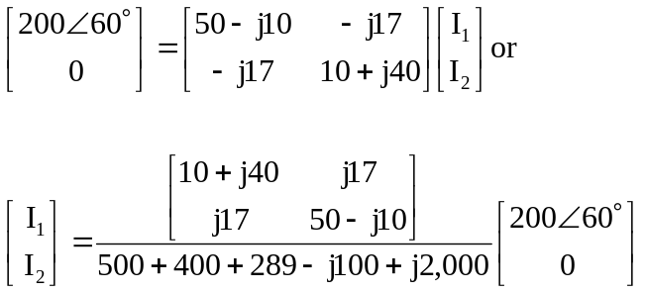

I₁ = (10+j40)(200∠60°)/(1,189+j1,900)
= (41.231∠75.964°)(200∠60°)/(2,241.4∠57.962°) = 3.679∠78° A and
I₂ = j17(200∠60°)/(2,241.4∠57.962°) = 1.5169∠92.04° A

I_{o} = I₂ = 1.5169∠92.04° A

It should be noted that switching the dot on the winding on the right only reverses the direction of I_{o}.

